Las Vegas Christian Chinese Church
Accident Waiver And Release Of Liability Form

Name of the Event: Vacation Bible School 2023

Date of Event: June 26 ~ 30, 2023 5:30 ~ 8:45 PM

Event Location: 8978 W Nevso, Las Vegas, Nevada, 89147

I hereby assume all of the risks of participating and/ or volunteering in this event including by way of example and not limitation, any risks that may arise from negligence or carelessness on the part of the persons or entities being released, from dangerous or defective equipment or property owned. Maintained, or controlled by them, or because of their possible liability without fault.

I certify that I am physically fit and have not been advised to not participate by a qualified medical professional. I certify that there are no health-related reasons or problems, which preclude my participation in this event.

I acknowledge that this Accident Waiver and Release of Liability Form will be use by the event holders, sponsors, and organizers of the event in which I may participate and that it will govern my actions and responsibilities at said event. I acknowledge that this event may involve a test of a person’s physical and mental limits and may carry with it the potential for death, serious injury, and property loss. The risks may include, but are not limited to, those caused by terrain, facilities, temperature, weather, condition of participants, equipment, vehicular traffic, actions of other people including, but not limited to participants, volunteers, spectators, event officials, and event monitors and/ or producers of the event, and lack of hydration. These risks are not only inherent to participants, but are also present for volunteers.

I hereby consent to receive medical treatment, which may be deemed advisable in the event of injury, accident, and/ or illness during this event.

I understand that at this event, I may be photographed. I agree to allow my photo, video, or film likeness to be used for any legitimate purpose by the event holders, producers, sponsors, organizers, and assigns.

The accident waiver and release of liability shall be construed broadly to provide a release and waiver to the maximum extent permissible under applicable law.

I certify that I have read this document and I fully understand its content. I am aware that this is a release of liability and a contract and I sign it of my own free will.

_______________________ _____________ _________________
Participant Name (Print) Date Participant Signature

PARENT / GUARDIAN WAIVER FOR MINORS (under 18 years old)

The undersigned parent and natural guardian does hereby represent that he/she is, in fact, acting in such capacity, has consented to his/her child or ward’s participation in the event, and has agreed individually and on behalf of the child or ward, to the terms of the accident waiver and release of liability set forth above. The undersigned parent or guardian further agrees to save and hold harmless and indemnify each and all of the parties referred to above from all liability, loss, cost, claim, or damage whatsoever which may be imposed upon said parties because of any defect in or lack of such capacity to so act and release said parties on behalf of the minor and the parents or legal guardian.

____________________ ____________ _________________________
Participant Parent Name Date Participant Parent /Guardian Signature
(Print)
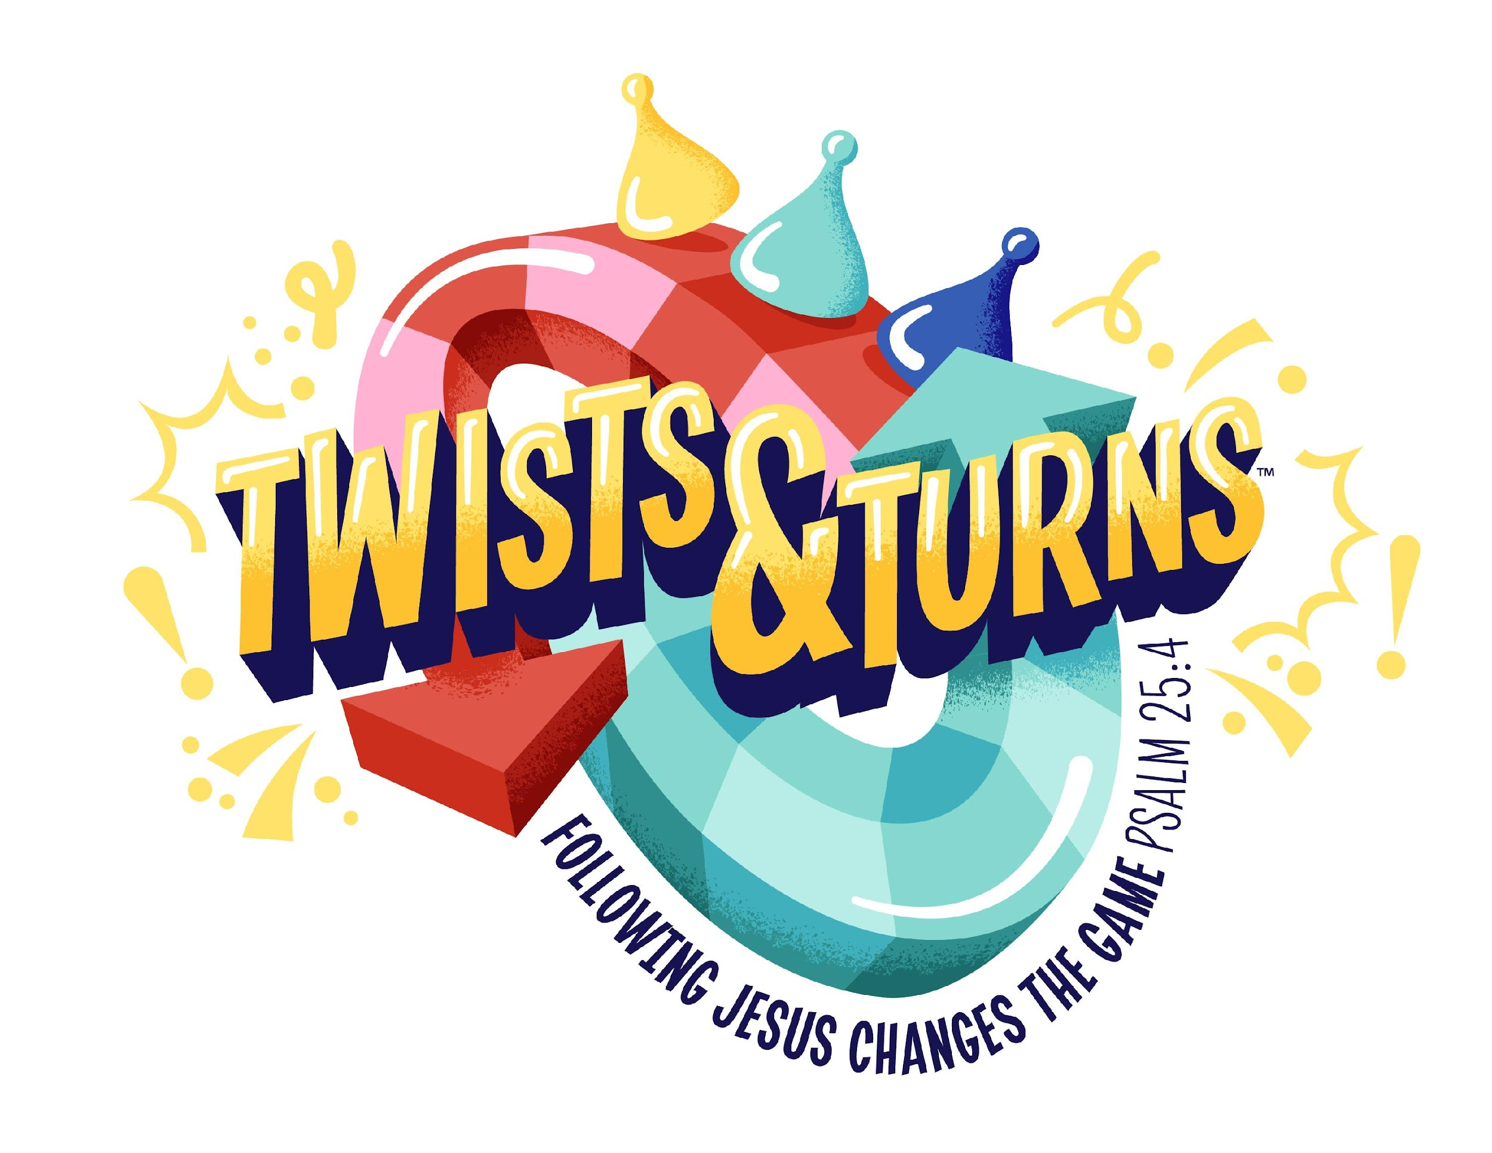

LVCCC Children's Ministry VBS 2023 -- Twists & Turns

Name姓名 _________________________ Birthday生日 ______________ Gender 性別 _________

Parent’s name 家長姓名 _____________________________

Address 住址_________________________________________________________________

Phone number電話號碼 _____________________________

Parent’s E-mail 電子郵箱_________________________

Allergies or other medical conditions 是否有任何過敏或藥物服用? 如果有, 請說明:

__________________________________________________________________________________

School grade for 2023-2024 _______________ T- Shirt size (circle one): S M L XL



Model Release Agreement

I, the undersigned, parent or legal guardian of below named minor do hereby acknowledge my understanding that photos, video, and/or audio footage may be taken during the below event which may include images of my child.
I understand that those images may be used in future publications, or other related purpose.

I hereby give Las Vegas Chinese Christian Church the irrevocable right to use those images in any image form, including composite or distorted representations, for the church use purpose.
I further waive any right to inspect or approve the finished product, including written copy, created in connection with these images.

_________________________________________________________
Name of Child (please print)

_______________________________________________
Name of Parent/Guardian (please print):

____________________________________________________________
Signature of Parent/Guardian:

Event: Vacation Bible School 2023

Event Dates: June 26 ~ 30,2023

Event Location: 8978 W Nevso Dr. Las Vegas, NV 89147

